**SUPPLEMENTARY FIGURE S12: Complete Thesis analysis overview**

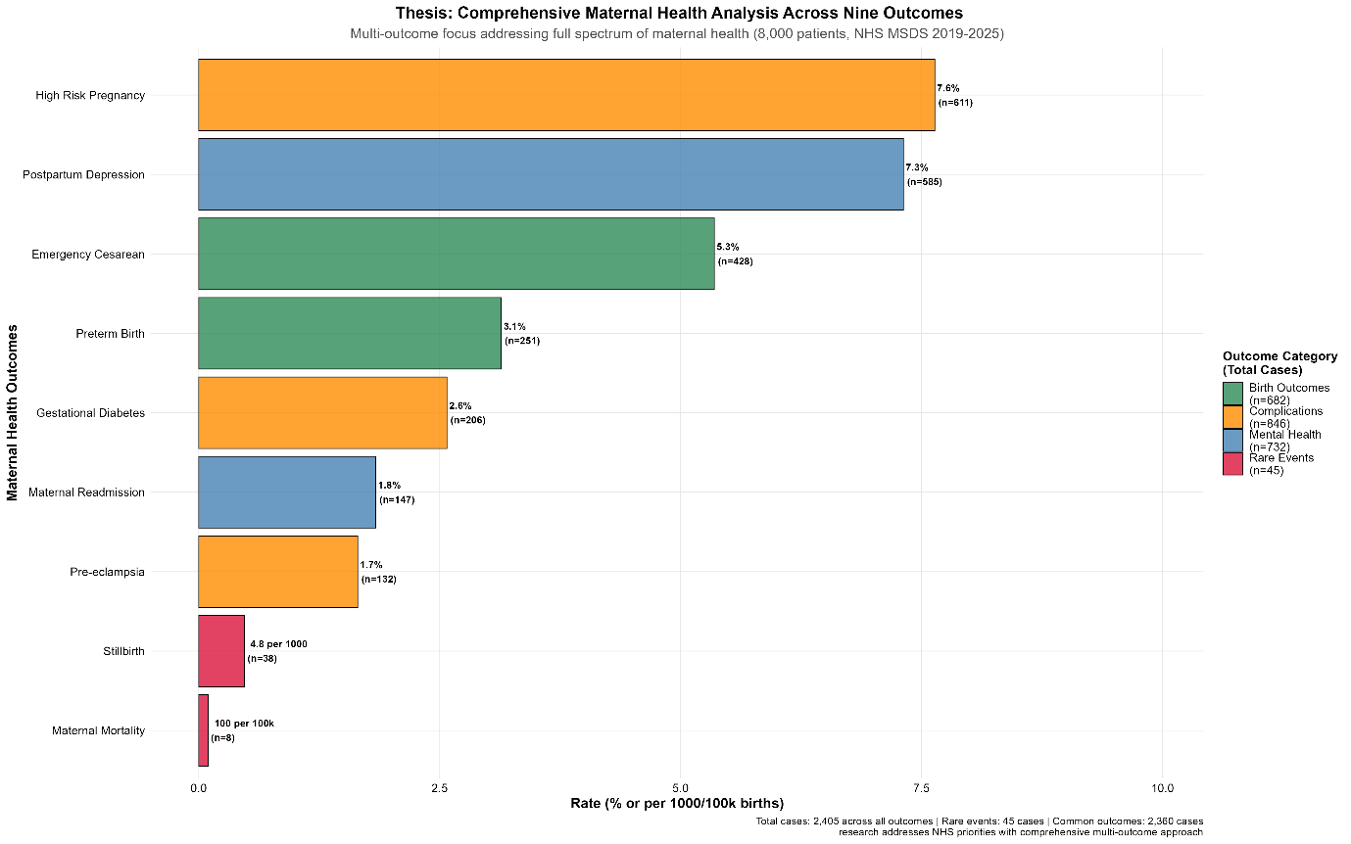

Comprehensive thesis analysis overview showing rates across nine maternal health outcomes analysed. Multi-outcome focus addressing full spectrum of maternal health (8,000 patients, NHS MSDS 2019-2025). Total case analysis: 2,405 across all outcomes with 45 rare events and 2,360 common outcomes. Demonstrates scope of comprehensive analytical approach beyond traditional single-outcome studies.